* Go to Anaconda website in <https://www.anaconda.com/distribution/>.
* Click on "Download"



* There are three different OS system. You can choose the one appropriate for your system. On this example, we select “Windows”.

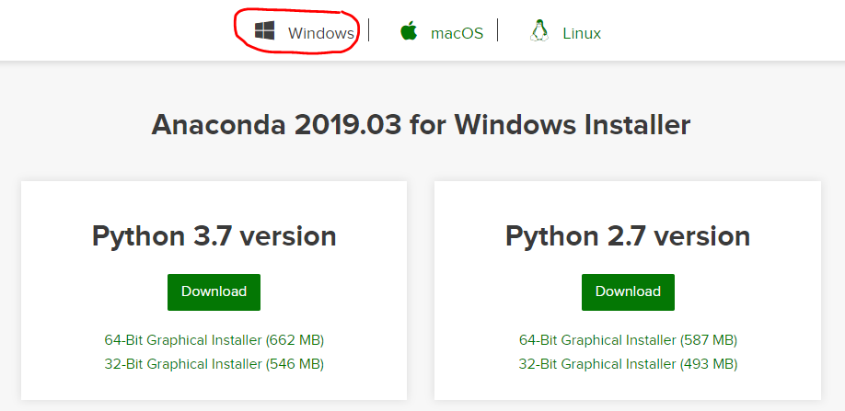

* In next screen, download Python 3.7 version.

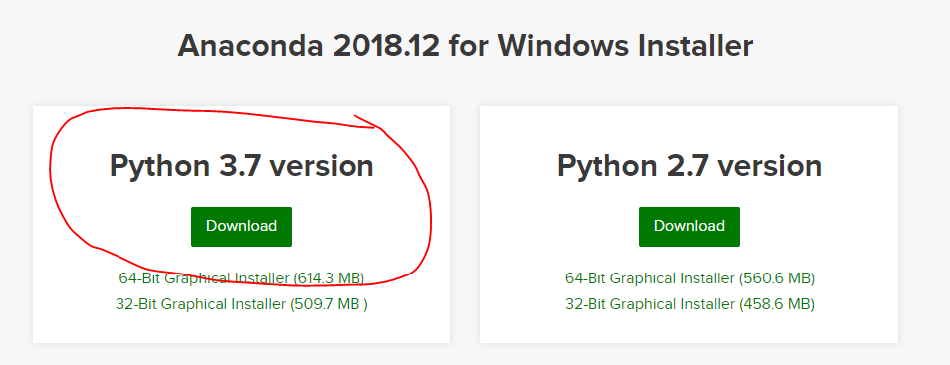

* It will download executable files Anaconda - Anaconda3-2018.12-Windows-x86_64.exe.
* Open Anaconda executable file and follow the instructions to install Anaconda (Jupyter notebook).
* Once Anaconda is installed, you will see "Anaconda Prompt" application in your computer.

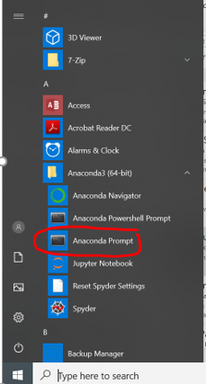

* Click on “Anaconda Prompt”. It will open “Anaconda Prompt” Command line as shown below.

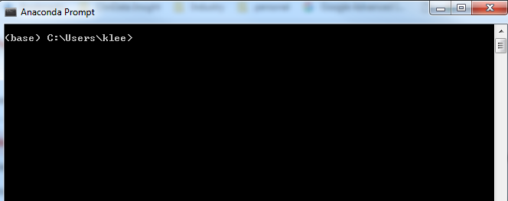

* Change the directory to where your python codes are saved by typing “cd …” and enter it.

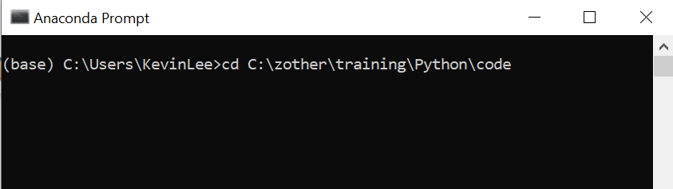

* Type “jupyter notebook” and enter

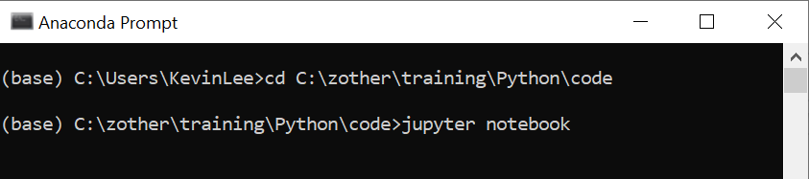

* It will open Jupyter notebook in your browser like below.

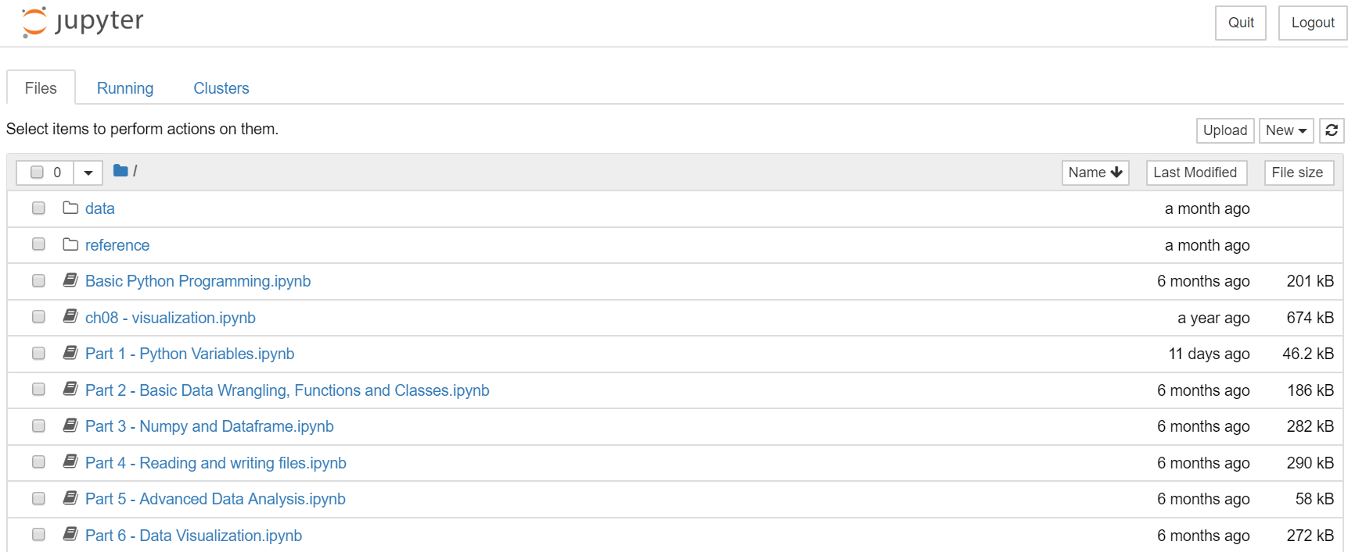

* You can click any program. Here, let’s click on “Part 1 – Python Variables”.

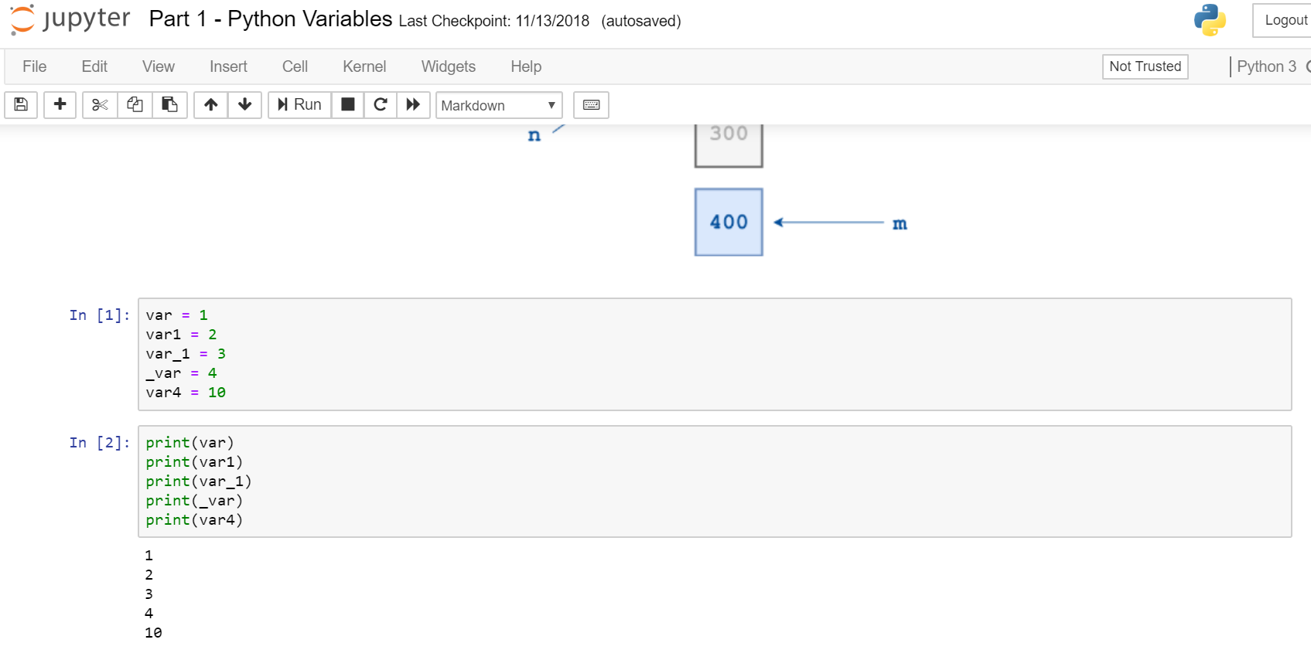

* Now, you can run your Python Program in Jupyter notebook.

Once Anaconda Prompt is installed, you can download Python Machine Learning Algorithms - keras, tensorflow, sklearn, scipy and scikit-image.   For example, type “conda install scikit-image” on “Anaconda Prompt” command line as shown below.

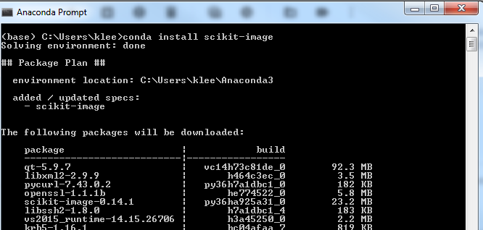

Enjoy Jupyter notebook!!!